Northern Illinois Conference
United Methodist Church
2016

Church benefit for Kenyan orphanage and school
Categories: Aurora,Chicago Northwestern,Chicago Southern,DeKalb,Elgin,News,Rockford
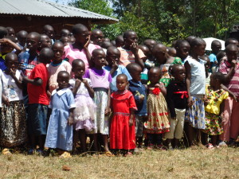
By Kay Mills
Halfway around the world we discovered a different way of life. When our friend, Gama, said he was returning home after 20 years and asked us to go with him, we were hesitant but curious. We were amazed to discover how people lived without running water, intermittent electricity, a village well, and walked everywhere they needed to go. Schools were crowded with few books, few teachers, and poor buildings. One school we visited did not have water and children were required to carry a container of water from the village well for the day.
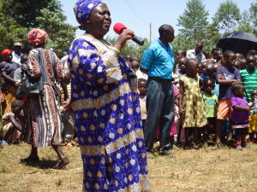
Mama Alice (Gama Aywa) greets the crowd gathered
Over 1,000 people from around the area walked to one location to welcome us. There was native singing and dancing and speeches, and then we experienced feeding the crowd. There seemed to be an endless line of orphans (over 500) who waited patiently with a bowl to receive a small scoop of rice, a little broth and two small pieces of meat. We learned that this would probably be their only meal for the day.
Mama Alice, Gama’s mother, is a pastor and peasant farmer in Kakamega who has helped needy children for years. She realized that there are more children than she can help alone, so she created the Mama Alice Foundation Irechelo in order to build a school and orphanage. After learning that in spite of their struggles and the adverse conditions, all these people still love and worship God.
Benefit to raise funds
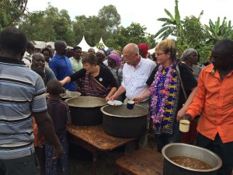
(L-R) Kay Mills, Roger Klemm and Cheryl Kirk help to feed the thousand people gathered for a meal after the program
On our way back to the United States, God put it in our hearts to have a fundraiser to contribute to Mama Alice’s dream. So we are sharing our experience through a video presentation and a “Kenyan Style” meal on April 30 at 4:00 pm at Cornerstone United Methodist Church, 41W170 Russell Road, Elgin, IL 60124. Donation tickets are $20.00 and can be obtained through Roger Klemm, PO Box 6163, Elgin, IL 60121 or by calling him at 630-234-6628. In case you are unable to attend, donations will be graciously accepted!
ALL proceeds will go directly to the Mama Alice Foundation in Kenya to help build the orphanage and school.
Click here to download a flyer.

