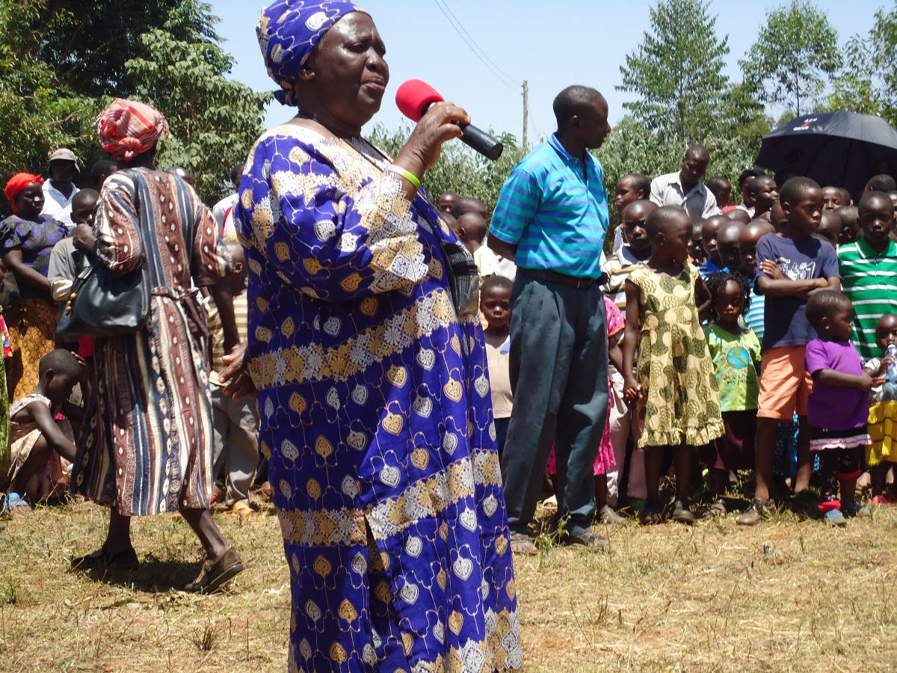

MAMA ALICE FOUNDATION IRECHELO

Mama Alice, a resident of Busilwa Irechelo village, is a devoted Christian and pastor who honors those who struggle to bring freedom, peace, and prosperity to their village. She respects the environment and heritage of her people, and protects the well-being of the individual, family, community, and county.

Busilwa is a small village of about 1000 square meters in Kakamega county in Kenya, Africa with a population of more than 10,000. Its main food is corn cake that is baked using firewood and a cooking stick, and is eaten with vegetables and meat.

Languages spoken in the village are Kiluhyia, Kiswahili and English (for those who are blessed to go to school). Singing and dancing are the main activities, as well as going to church.

Mama Alice has helped needy children for more than 20 years and has helped many pursue higher levels of education. She realized her funds from peasant farming were not enough to support the large number of orphans, even with additional funds sent from America by her son, Gama. Thus, she has started the “Mama Alice Foundation” to feed educate, shelter, and provide clothing for more than 500 orphans. She realizes children cannot learn and have a brighter future unless their physical needs are met.

Mama Alice and her committee, which includes the chairman, Mr. Naftali Munuobi, is working hard to see that the children are cared for. Currently the children go to different schools but come to Irechelo for lessons on Saturday. Funds are needed to pay teachers, provide food, and uniforms so these children can come to one place to live and receive food and education. The field were we convened is the ground she has selected for her dream of building the orphanage. She requires more funds to buy the land, build the school/orphanage. Therefore, she is appealing to well-wishers who can help her fulfill her dream to help more children. Thank you and God bless!

